|  |
| --- |
| **NiSource** |
| **Columbia Pipeline Group (CPG)** |
| **Design Specification (SDS)**  **Project: NiPADS ProTool Enhancements** |

**Business Unit(s): CPG Engineering & Construction**

Document Version: 1.0

**Open Items**

1. Need to determine how ProTool authentication works – Follow up with Bruner
2. Need to determine how to capture authorization roles (Viewer, User, Admin, etc) once authenticated within ProTool.
3. Need to add a business rule for Locking Date

1 Application Architecture 4

1.1 Solution Architecture Diagram 4

1.2 Technical Process Diagram 5

1.3 Site Map 5

1.4 Batch Processes 5

1.5 Functional scalability 5

1.6 Error Messages 5

2 Application Component Design 6

2.1 Field Cost Tracker Excel Spreadsheet Template 6

2.1.1 Forecast Summary Worksheet 6

2.1.2 Forecast Tracking Worksheet for Each Period 9

2.1.3 Import Forecast Worksheet to ProTool (Button Macro): 14

2.1.4 Copy to New Sheet (Button Macro): 16

3 Information Architecture 18

3.1 Logical Data Model 18

3.2 Physical Data Model 18

3.2.1 ProTool Data Source 18

3.3 Data Conversion Specifications 22

4 Infrastructure Architecture 23

4.1 Environment Topology diagrams 23

4.2 IT Resources 23

4.3 Security Specifications and Access Matrix 23

4.4 Backup and Recovery Design 24

5 Revision History 24

# Application Architecture

The solution will consist of the following major parts. Refer to the solution architecture diagram that follows.

1. **Forecast Spreadsheet Template** – Users shall create a new spreadsheet from a standardized template (available from a SharePoint site) for each project that they wish to track. In leveraging Microsoft Excel, the project delivery and operations teams will have the ability to customize and track estimates offline; uploading them to ProTool once connected. The template shall contain button macros and VBA components for exporting and importing updated forecast information from/into ProTool.
2. **ProTool Database Components** – The solution will leverage existing tables found within ProTool SQL Server 2008 R2 database including: EstimateYears (Forecast), EstimateYearbyCategories (Budget), AuditEvents, Audits, Projects, LockingDateByMonth, and CostCategories (Project Cost Groups). The EstimateYears tables will be the primary table used to export and import forecast information. The rest of the tables will be used to support cursory data on the spreadsheet template or used to validate business rules. Access to the ProTool database and necessary stored procedures will be controlled using Windows Integrated security and Active Directory.

## Solution Architecture Diagram



## Technical Process Diagram

The following shows the technical process of the solution:

Insert Technical Process Diagram

## Site Map

Not applicable. The user interface (UI) portion of the solution is the Microsoft Excel spreadsheet template.

## Batch Processes

Not applicable. There are no batch processes associated with this solution.

## Functional scalability

Existing hardware, software, and network infrastructure used by ProTool shall be leveraged for this solution. All UI processing shall be distributed to the end-users computers via the Excel VBA macros.

## Error Messages

1. **Field Cost Tracker Excel Spreadsheet Template**

Technical detail of any program exception or invalid data state will be stored in a hidden “DEBUG” worksheet tab (1st sheet before Forecast Information), but not displayed or visible to end-users. This will serve useful to IT staff in any debugging effort. IT support can ask the user for a copy of the Excel Spreadsheet and unhide the “DEBUG” worksheet tab.

User-friendly messages will display to users in two types:

1. Generic message letting the user know an internal program error occurred during processing.
2. High level, short message that describes any invalid data value or data state determined during processing.

1. **ProTool Database Components**

Any SQL Server errors including those thrown from within stored procedures will be rolled up to the Excel Spreadsheet VBA code for handling as described previously.

# Application Component Design

## Field Cost Tracker Excel Spreadsheet Template

The Excel spreadsheet makes up the entire user interfaces for this solution.

### Forecast Summary Worksheet

Create an Excel 2010 macro-enabled spreadsheet template with detail designs as described in sub-sections below.

#### Get Forecast (Button Macro) - Screens

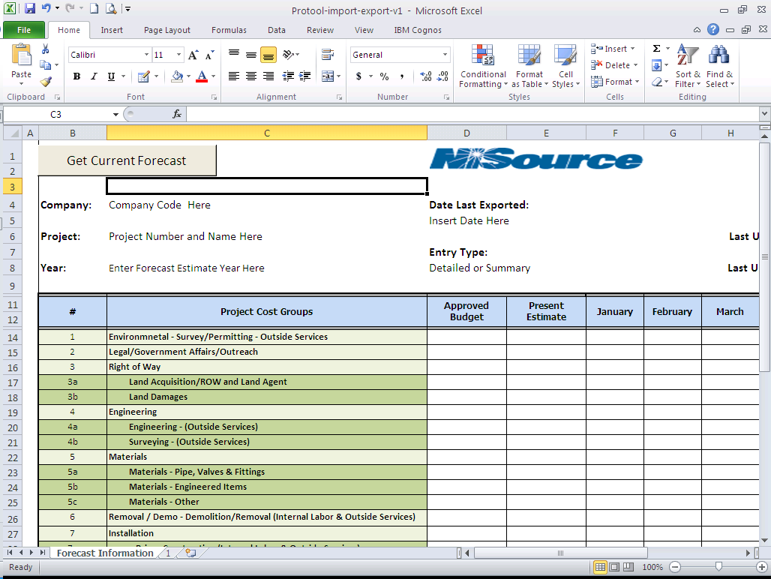

#### Get Forecast (Button Macro) – Functionality

| **Sections** | **Field(s)** | **Control / Validation** | **Data Mapping** | **Notes** |
| --- | --- | --- | --- | --- |
| Header | Company | Protected cells | From user prompt |  |
| Project (Number & Name) | Protected cells | ProTool.Projects. Project_No  ProTool.Projects. Title |  |
| Forecast Year | Protected cells | From user prompt |  |
| Date Last Exported | Protected cells | ProTool.Audit.Audit_Date | Where  Company_Cd=User Prompt  Project_No= User Prompt  User_ID = **USER**  Audit_Event_ID=TBD |
| Entry Type | Protected cells | ProTool.Estimates.Cost_Category_Type |  |
| Last Forecast Update User | Protected cells | TBD  From the Audit table |  |
| Last Forecast Update Date | Protected cells | TBD  From the Audit table |  |
| Get Current Forecast | Button click |  | VBA Macro to prompt user for PO# and get data from ProTool db. |
| Line Detail | Project Cost Group # | Protected cells | ProTool.CostCategories.Cost_Category_Cd |  |
| Project Cost Group | Protected cells | ProTool.CostCategories.Cost_Category_Desc | If Entry Type is Summary, where Cost_Category_Type=**Summary**  If Entry Type is Detailed, where Cost_Category_Type=**Detail** |
| Approved Budget | Protected cells | ProTool.EstimateYearsByCategories.Amount | WHERE Company_Cd = *Prompt Value,* Project_No= *Prompt Value*, Estimate_Year=*Prompt_Value* and Estimate_Version=MAX(Estimate_Vesion) for Estimate Year  Broken down by Cost_Category_Cd |
| Present Estimate | Protected cells | Calculation | Sum of all months |
| January | Protected cells | ProTool.EstimateYears.January |  |
| February | Protected cells | ProTool.EstimateYears.February |  |
| March | Protected cells | ProTool.EstimateYears.March |  |
| April | Protected cells | ProTool.EstimateYears.April |  |
| May | Protected cells | ProTool.EstimateYears.May |  |
| June | Protected cells | ProTool.EstimateYears.June |  |
| July | Protected cells | ProTool.EstimateYears.July |  |
| August | Protected cells | ProTool.EstimateYears.August |  |
| September | Protected cells | ProTool.EstimateYears.September |  |
| October | Protected cells | ProTool.EstimateYears.October |  |
| November | Protected cells | ProTool.EstimateYears.November |  |
| December | Protected cells | ProTool.EstimateYears.December |  |
| Pop-up Dialogs | Enter Company Code, Project Number and Estimate Year | Validate value is numeric | Filter on ProTool.EstimateYears.Company_Cd, ProTool.EstimateYears.Project_No, and ProTool.EstimateYears.Estimate_Year | Prompts user on click of “Get Forecast” button. |

To get the list of **Company Codes**:

SELECT [Company_Cd]

FROM [Protool_staging].[ProTool].[Company]

WHERE Active_Fl='1'

Order by Company_Cd

To get **Project Status**:

SELECT [Project_Status_Cd] FROM [Protool_staging].[ProTool].[Projects]

WHERE [Company_Cd]='TCO'

AND Project_No = ' 17024'

Replace TCO with desired Company CD

Replace 17160 with the desired Project Number

To get **Approved Budget (broken down by Cost Category)**:

SELECT [Cost_Category_Cd]

,[Amount]

FROM [Protool_staging].[ProTool].[EstimateYearByCategories]

WHERE Company_Cd='TCO' AND Project_No='17024' AND Estimate_Year='2013' AND [Version_No]=

(SELECT Version_No FROM [ProTool].[ProTool].[EstimateYears]

WHERE Company_Cd='TCO' AND Project_No='17024' AND Estimate_Year='2013' AND Year_Approval_Fl=1)

To get **Forecast Information**:

SELECT [Cost_Category_Cd]

[January]

,[February]

,[March]

,[April]

,[May]

,[June]

,[July]

,[August]

,[September]

,[October]

,[November]

,[December]

FROM [ProTool].[ProTool].[EstimateYears]

WHERE Company_Cd='TCO' AND Project_No='17024' AND Estimate_Year='2013' AND Version_No =

(SELECT MAX(Version_No) FROM [ProTool].[ProTool].[EstimateYears] WHERE Company_Cd='TCO' AND Project_No='17024' AND Estimate_Year='2013')

**Note: We need to update the test environment Estimate Years table to include Cost Category.**

To get **Cost Cateogry Information:**

SELECT [Cost_Category_Cd]

,[Cost_Category_Desc]

,[Cost_Category_Type]

FROM [Protool_staging].[ProTool].[CostCategories]

Gives you the number that goes in Column C and the Name that goes in Column D.

The Type is used to determine whether it is Summary or Detailed.

#### Get Forecast (Button Macro) – Business Rules

| **Rule ID** | **Business Rule Description** | **Notes** |
| --- | --- | --- |
|  | Use Windows integrated security to confirm the user has a ProTool role (IT_ADMIN, MARKET_DEV, ADMIN, CA, EC_MANAGER, USER, VIEWER ) before allowing them to retrieve the project forecast information. Any ProTool role can retrieve the forecast information. If the user is not a ProTool role, please display a user friendly message indicating that they need to request access to the ProTool application via an AccessIT request. |  |
|  | Protect the entire Forecast Information worksheet tab. Users cannot modify layout or content. They can click the button to retrieve or refresh forecast information as many times desired. |  |
|  | Upon selection of the **Export Forecast** button, Verify VPN access and display user-friendly message if no connectivity. |  |
|  | If the user has VPN access, (and the first time exporting the forecast) the user should be prompt to select a company code (from a dropdown list) and enter a project number and estimate year. The information shall be stored along with the spreadsheet in a hidden view. |  |
|  | Following the first export, the spreadsheet should not prompt the user for the company code, project number, nor estimate year. It should use the values hidden within the spreadsheet. |  |
|  | To create a new project or estimate year spreadsheet, users will have to download the template from the ProTool website. |  |
|  | After getting the Company Code, Project Number, and Estimate Year, validate that the project status is Active. Display a user-friendly message if Project status is not Active (Project_Status_Cd=1). Terminate data import. | Validation – Project Status |
|  | When the entered estimate year does not exists for the project, display user-friendly message and prompt the user to enter a new estimate year (keep the company code and project number values) | Validation – Year (Left Join) |
|  | For all past months, the numbers shall be bold (indicating they are actuals) |  |
|  | If the entry type for the project is Summary (Cost_Category_Type=1) only the summary project cost groups shall be displayed. If the Entry Type for the project is Detailed (Cost_Category_Type=2), only the detailed project cost groups shall be displayed. If the Entry Type for the project is Null, only the summary project cost groups shall be displayed. | Cost_Category_Type is 1 or NULL show Summary else Detail. |
|  | The Forecast imported from the ProTool database shall correspond to the MAX Estimate Version for the entered Estimate Year to be retrieved |  |
|  | Present Estimate is the sum of all month columns for a year. |  |

### Forecast Tracking Worksheet for Each Period

The layout and content is protected for the header rows. The display of the project cost groups (Summary or Detail) will be determined by the Entry Type (pulled from the Estimates table in ProTool). While the Summary or Detail rows will be protected, a user can add and update any rows between the project cost groups. The Project Cost Group row will sum up the totals in between; this is the number that will be submitted back into ProTool. While users cannot modify the columns (A – R) within the table, they are able to edit (add/delete columns, etc.) anything outside of the table.

#### Forecast Tracking Worksheet - Screens

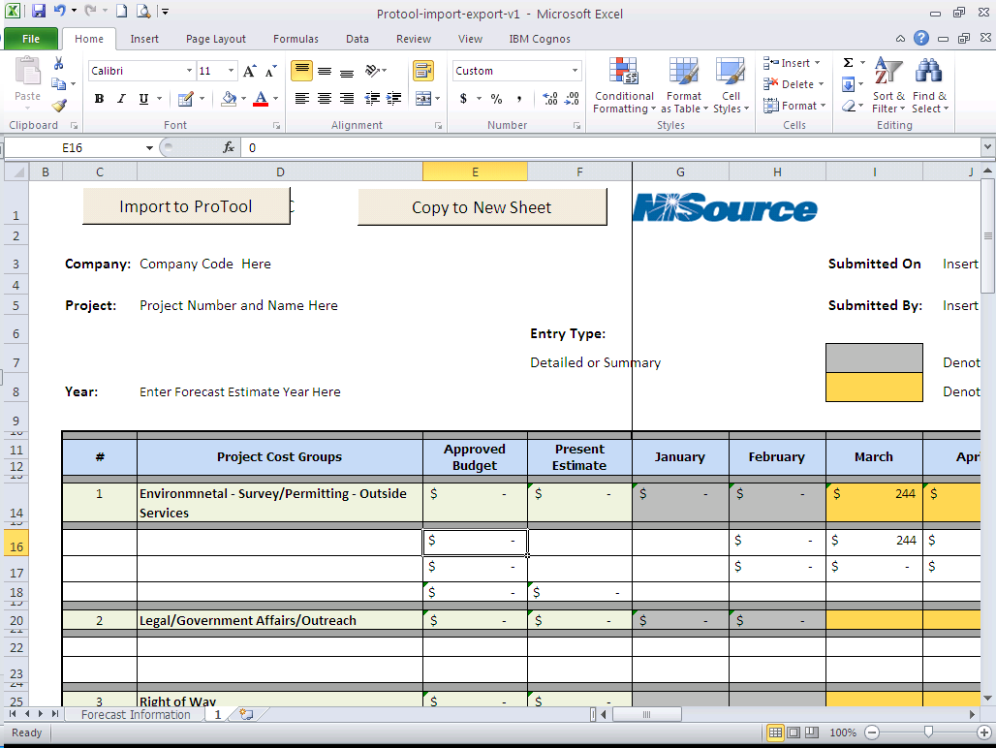

#### Forecast Tracking Worksheet – Functionality

| **Sections** | **Field(s)** | **Control / Validation** | **Data Mapping** | **Notes** |
| --- | --- | --- | --- | --- |
| Header | Company | Protected cells | Marco copied from Forecast Information tab |  |
| Project (Number & Name) | Protected cells | Marco copied from Forecast Information tab |  |
| Forecast Year | Protected cells | Marco copied from Forecast Information tab |  |
| Entry Type | Protected cells | Marco copied from Forecast Information tab |  |
| Submitted On | Protected cells | Macro updates upon successful submit | Date and time submitted. |
| Submitted By | Protected cells | User’s network id that submitted. |
| Import into ProTool | Button macro |  | On click VBA code will submit the updated forecast to the EstimateYears table. The VBA code will also record an auditable action and update the summary sheet. |
| Copy to New Sheet | Button macro |  | On click VBA code will retrieve the latest forecast from ProTool, populate the Summary Spreadsheet, then copy the current worksheet into a new tab, update the budget and forecasts for the primary and secondary project cost group rows, and clears all the detail amounts (in between the project cost groups) for the new period. |
| Primary and Secondary Cost Group Rows | Project Cost Group# | Protected cells | Marco copied from Forecast Information tab |  |
| Project Cost Group | Protected cells | Marco copied from Forecast Information tab |  |
| Approved Budget | Protected cells | Marco copied from Forecast Information tab |  |
| Present Estimate | Protected cells | Calculated | Sum of all months for that row |
| January |  | Marco copied from Forecast Information tab |  |
| February |  | Marco copied from Forecast Information tab |  |
| March |  | Marco copied from Forecast Information tab |  |
| April |  | Marco copied from Forecast Information tab |  |
| May |  | Marco copied from Forecast Information tab |  |
| June |  | Marco copied from Forecast Information tab |  |
| July |  | Marco copied from Forecast Information tab |  |
| August |  | Marco copied from Forecast Information tab |  |
| September |  | Marco copied from Forecast Information tab |  |
| October |  | Marco copied from Forecast Information tab |  |
| November |  | Marco copied from Forecast Information tab |  |
| December |  | Marco copied from Forecast Information tab |  |
| Line Detail (white rows) | Project Cost Group# | User Defined |  |  |
| Project Cost Group | User Defined |  |  |
| Approved Budget | Protected cells | Empty |  |
| Present Estimate | Protected cells | Calculated | Sum of all months for that row |
| January | Protected for past months;  Unprotected for all future months |  |  |
| February | Protected for past months;  Unprotected for all future months |  |  |
| March | Protected for past months;  Unprotected for all future months |  |  |
| April | Protected for past months;  Unprotected for all future months |  |  |
| May | Protected for past months;  Unprotected for all future months |  |  |
| June | Protected for past months;  Unprotected for all future months |  |  |
| July | Protected for past months;  Unprotected for all future months |  |  |
| August | Protected for past months;  Unprotected for all future months |  |  |
| September | Protected for past months;  Unprotected for all future months |  |  |
| October | Protected for past months;  Unprotected for all future months |  |  |
| November | Protected for past months;  Unprotected for all future months |  |  |
| December | Protected for past months;  Unprotected for all future months |  |  |
| Sheet Totals | Monthly Totals | Protected cells | Formula: Sum of all Project Cost Group row amounts for the corresponding month. |  |

#### Forecast Tracking Worksheet – Business Rules

| **Rule ID** | **Business Rule Description** | **Notes** |
| --- | --- | --- |
|  | The user must be a member of one of the following roles in order to import a forecast: **(ADMIN, EC_MANAGER, USER)** |  |
|  | If the user is not of a ProTool import role, a user friendly message indicating shall be displayed that they need to request access to the ProTool application via an AccessIT request. |  |
|  | Upon selection of the Import into ProTool button, Verify VPN access and display user-friendly message if no connectivity. |  |
|  | After validation the VPN connection, validate that the project status is Active. Display a user-friendly message if Project status is not Active (Project_Status_Cd=1). Terminate data import. |  |
|  | For all past months, the numbers shall be bold (indicating they are actuals), read-only, and greyed out. |  |
|  | If the entry type for the project is Summary (Cost_Category_Type=1) only the summary project cost groups shall be displayed. If the Entry Type for the project is Detailed (Cost_Category_Type=2), only the detailed project cost groups shall be displayed. If the Entry Type for the project is Null, only the summary project cost groups shall be displayed. |  |
|  | The Project Cost Groups shall be read-only. They should be a sum of all rows in between the Project Cost Groups for those columns that are **not** the Approved Budget, Present Estimate, or Past Months. |  |
|  | Users shall have the ability to insert/update all rows and content in between the project cost groups for those columns that are **not** the Approved Budget, Present Estimate, or Past Months. |  |
|  | For all future months in Project Cost Group (that are actually going to be submitted) the background color should be orange. |  |
|  | Present Estimate is the sum of all month columns for a year. |  |
|  | Users shall be provided the ability to add content to cells that are outside the framed grid (Columns A-R) to the right |  |
|  | Users are not permitted to insert columns, but can enter content into columns to the right of the framed grid. |  |
|  | When importing the content into ProTool, all updates shall be applied to the Max Estimate Version in the Estimate Year table corresponding to the company code/project number/estimate year of the Excel workbook. |  |
|  | For those rows in the Excel spreadsheet in which the cost category code already exists for the company code/project number/estimate year/estimate version combination, the rows shall be updated. |  |
|  | For those rows in the Excel spreadsheet in which the cost category code does not already exists in the Estimate Year table for the corresponding company code/project number/estimate year, the rows shall be inserted. |  |
|  | The monthly total row at the bottom of the page shall be a sum of all project cost group rows for that particular column. |  |
|  |  |  |

### Import Forecast Worksheet to ProTool (Button Macro):

#### Import Forecast Worksheet - Screens



#### Import Forecast Worksheet – Functionality

| **Sections** | **Field(s)** | **Control / Validation** | **Data Mapping** | **Notes** |
| --- | --- | --- | --- | --- |
| Header | Submitted On | Protected cells | Macro updates upon successful submit | Date and time submitted. Submit macro should not continue if this date value already exists. |
| Submitted By | Protected cells | User’s network id that submitted. |
| Import to ProTool | Button macro |  | On click VBA code will submit the updated forecast to the EstimateYears table. The VBA code will also record an auditable action and update the summary sheet. |
| Success pop-up dialog | Ok | Button | Click to close dialog and return to worksheet. | Dialog informs user when the submit has completed successfully. |
| Failure pop-up dialog | Ok | Button | Click to close dialog and return to worksheet. | Dialog informs user when a validation or error occurred and processing has aborted. |
| Submit Fields | Company Code (Header section) | Protected cell | ProTool.EstimateYears.Company_Cd | An Update Statement will be used (instead of an insert statement) to retain the flags in the EstimateYears row |
| Project Number (Header) | Protected cell | ProTool.EstimateYears.Project_No |
| Estimate Year (Header) | Protected cell | ProTool.EstimateYears.Estimate_Year |
| Estimate Version | Protected cell | ProTool.EstimateYears.Version_No |
| Project Cost Group # |  | ProTool.EstimateYears.Cost_Category_Cd |
| January |  | ProTool.EstimateYears.January |
| February |  | ProTool.EstimateYears.February |
| March |  | ProTool.EstimateYears.March |
| April |  | ProTool.EstimateYears.April |
| May |  | ProTool.EstimateYears.May |
| June |  | ProTool.EstimateYears.June |
| July |  | ProTool.EstimateYears.July |
| August |  | ProTool.EstimateYears.August |
| September |  | ProTool.EstimateYears.September |
| October |  | ProTool.EstimateYears.October |
| November |  | ProTool.EstimateYears.November |
| December |  | ProTool.EstimateYears.December |

#### Import Forecast Worksheet – Business Rules

| **Rule ID** | **Business Rule Description** | **Notes** |
| --- | --- | --- |
|  | Clicking the “Import into ProTool” button submits the current worksheet. |  |
|  | The entire worksheet is protected if the submit is successful and the Import into ProTool button is disabled. |  |
|  | The user name and date/time submitted is automatically updated in the upper-right hand corner of the header rows. |  |
|  | The button macro will not allow the user to submit the same sheet more than once unless the first attempt failed with error. |  |
|  | A user-friendly message should display upon any failed validation or internal processing error. |  |
|  | Following a successful submission into ProTool, the Forecast Information should be updated with the newly submitted forecast. |  |
|  |  |  |

### Copy to New Sheet (Button Macro):

Clicking the “Copy to New Sheet” button will create a new worksheet. It always copies from the last worksheet tab no matter which worksheet the button is selected.

#### Copy to New Sheet - Screens



#### Copy to New Sheet – Functionality

| **Sections** | **Field(s)** | **Control / Validation** | **Data Mapping** | **Notes** |
| --- | --- | --- | --- | --- |
| Header | Copy to New Sheet | Button macro |  | On click VBA code will retrieve the latest forecast from ProTool, populate the Summary Spreadsheet, then copy the current worksheet into a new tab, update the budget and forecasts for the primary and secondary project cost group rows, and clears all the detail amounts (in between the project cost groups) for the new period. |
| Submitted On |  |  | Macro clears both these values |
| Submitted By |  |  |
| Line Detail (white rows) | Forecast Information | User entered | n/a | Copy macro clears all these cell values. |
| Copy Sheet Success – Pop-up dialog | OK | Button | Click to close dialog and set focus to the new worksheet. |  |

#### Copy to New Sheet – Business Rules

| **Rule ID** | **Business Rule Description** | **Notes** |
| --- | --- | --- |
|  | Copy macro should:   1. Call VBA code that copies the detail spreadsheet into a new spreadsheet as is (no changes). 2. The VBA code should then retrieve the forecast information and update the forecast information tab 3. The VBA code should then compare the Project Cost Group rows of the copied spreadsheet with that in the forecast information tab.   For all past months, the numbers from the Forecast Information tab should be updated in the detailed tab (those numbers should be greyed out and read-only to the user).  For all future months where the forecast calculation for that project cost group/month is different than the forecast for that project cost group/month in the forecast information tab, the detailed tab number should be highlighted in red (indicating the difference) but the number should remain in the detailed tab as is. |  |
|  | For all past months, the numbers shall be bold (indicating they are actuals), read-only, and greyed out. |  |
|  | If the entry type for the project is Summary (Cost_Category_Type=1) only the summary project cost groups shall be displayed. If the Entry Type for the project is Detailed (Cost_Category_Type=2), only the detailed project cost groups shall be displayed. If the Entry Type for the project is Null, only the summary project cost groups shall be displayed. |  |
|  | Present Estimate is the sum of all month columns for a year. |  |
|  | The monthly total row at the bottom of the page shall be a sum of all project cost group rows for that particular column. |  |
|  |  |  |

# Information Architecture

## Logical Data Model

## Physical Data Model

### ProTool Data Source

The following ProTool tables will be used for this solution.

**Table: AuditEvents**

|  |  |  |  |  |
| --- | --- | --- | --- | --- |
| **Column Name** | **Data Type** | **Nullable** | **Indexes** | **Comments** |
| Audit_Event_ID | int | No | PK |  |
| Audit_Event_Dsc | varchar(500) | Yes |  |  |

An AuditEvent shall be added to the table for Forecast Export and a separate entry for Forecast Import.

**Table: Audit**

|  |  |  |  |  |
| --- | --- | --- | --- | --- |
| **Column Name** | **Data Type** | **Nullable** | **Indexes** | **Comments** |
| Company_Cd | int | No | PK |  |
| Project_No | varchar(500) | No | PK |  |
| User_ID | varchar(10) | No | PK |  |
| Audit_ID | Int | No | PK | Sequential number based on the User ID |
| Audit_Event_ID | Int | No |  | Pulled from AuditEvents table |
| Audit_Date | Datetime | No |  |  |
| Version_No | Smallint | Yes |  | Estimate Version |
| Estimate_Year | varchar(4) | Yes |  | Estimate Year |
| Scope_Version_No | Smallint | Yes |  | N/A to this solution as such it will be NULL |
| Admin_Fl | Bit | No |  | Denotes the ProTool role of the person making the auditable event. 1 if Admin, 0 if not. |

An Audit entry shall be added to the table each time the forecast is exported from or imported into ProTool.

**Table: Audit**

|  |  |  |  |  |
| --- | --- | --- | --- | --- |
| **Column Name** | **Data Type** | **Nullable** | **Indexes** | **Comments** |
| Company_Cd | int | No | PK |  |
| Project_No | varchar(500) | No | PK |  |
| User_ID | varchar(10) | No | PK |  |
| Audit_ID | Int | No | PK | Sequential number based on the User ID |
| Audit_Event_ID | Int | No |  | Pulled from AuditEvents table |
| Audit_Date | Datetime | No |  |  |
| Version_No | Smallint | Yes |  | Estimate Version |
| Estimate_Year | varchar(4) | Yes |  | Estimate Year |
| Scope_Version_No | Smallint | Yes |  | N/A to this solution as such it will be NULL |
| Admin_Fl | Bit | No |  | Denotes the ProTool role of the person making the auditable event. 1 if Admin, 0 if not. |

An Audit entry shall be added to the table each time the forecast is exported from or imported into ProTool.

**Table: EstimateYearByCategories**

|  |  |  |  |  |
| --- | --- | --- | --- | --- |
| **Column Name** | **Data Type** | **Nullable** | **Indexes** | **Comments** |
| **Company_Cd** | varchar(3) | No | PK |  |
| **Project_No** | Int | No | PK |  |
| **Cost_Category_Cd** | Smallint | No | PK | Determines the Project Cost Group to associate to the budget amount |
| **Version_No** | Smallint | No | PK |  |
| **Amount** | Int | No |  | The budget amount for a specific project, estimate year, version, project cost group. |
| **Estimate_Year** | varchar(4) | No | PK |  |
| Contingency | Int | Yes |  |  |
| User_Id | varchar(10) | Yes |  |  |
| Trans_Date | Datetime | Yes |  |  |
| January | Float | Yes |  |  |
| February | Float | Yes |  |  |
| March | Float | Yes |  |  |
| April | Float | Yes |  |  |
| May | Float | Yes |  |  |
| June | Float | Yes |  |  |
| July | Float | Yes |  |  |
| August | Float | Yes |  |  |
| September | Float | Yes |  |  |
| October | Float | Yes |  |  |
| November | Float | Yes |  |  |
| December | Float | Yes |  |  |

This table will need to be joined with the EstimateYears table (the EstimateYears table contains the Approved to Spend flag for a specific estimate year/version) to determine which rows in the EstimateYearByCategories table contain the budget information (broken down by Project Cost Group) to be pulled back in the summary tab in the tracker spreadsheet. Those fields indicated in bold (in the table above) are those fields that will be used for this solution.

**Table: EstimateYears**

|  |  |  |  |  |
| --- | --- | --- | --- | --- |
| **Column Name** | **Data Type** | **Nullable** | **Indexes** | **Comments** |
| Company_Cd | varchar(3) | No | PK |  |
| Project_No | Int | No | PK |  |
| Estimate_Year | varchar(4) | No | PK |  |
| Version_No | Smallint | No | PK |  |
| Cost_Category_Cd | Smallint | No | PK | This field needs to be added to the EstimateYears table |
| January | Float | Yes |  |  |
| February | Float | Yes |  |  |
| March | Float | Yes |  |  |
| April | Float | Yes |  |  |
| May | Float | Yes |  |  |
| June | Float | Yes |  |  |
| July | Float | Yes |  |  |
| August | Float | Yes |  |  |
| September | Float | Yes |  |  |
| October | Float | Yes |  |  |
| November | Float | Yes |  |  |
| December | Float | Yes |  |  |
| Year_Approval_Fl | Bit | Yes |  |  |
| Year_Approval_ID | varchar(10) | Yes |  |  |
| Year_Approval_Date | Smalldatetime | Yes |  |  |
| Budget_Version_Cd | Smallint | No |  |  |
| Preliminary_Program_FL | Bit | No |  |  |
| Original_Program_FL | Bit | No |  |  |
| Contingency | Float | Yes |  |  |
| User_ID | varchar(10) | Yes |  |  |
| Trans_Date | Datetime | Yes |  |  |

This is the table used to store the monthly forecasts. This is the primary table to be used in this solution.

**Table: LockingDateByMonth**

|  |  |  |  |  |
| --- | --- | --- | --- | --- |
| **Column Name** | **Data Type** | **Nullable** | **Indexes** | **Comments** |
| ID | int | No | PK |  |
| Month_Name | nvarchar(20) | No |  |  |
| DateToLock | Int | No |  | Determines the date in which all non-admin users are locked from the forecast interface |
| Admin DateToLock | Int | No |  | Determines the date in which the forecast interface is open for all future months to all users. The current month is officially closed on this date. |

This table will be used during submission as a validation step to determine whether the user can submit and which months the user is able to submit.

**Table: CostCategories**

|  |  |  |  |  |
| --- | --- | --- | --- | --- |
| **Column Name** | **Data Type** | **Nullable** | **Indexes** | **Comments** |
| **Cost_Category_Cd** | smallint | No | PK |  |
| Cost_Category_Key | varchar(75) | Yes |  |  |
| **Cost_Category_Desc** | varchar(75) | No |  |  |
| Capital_Active_Fl | Bit | No |  |  |
| Capital_Cost_Retire_Fl | Bit | Yes |  |  |
| OM_Active_Fl | Bit | No |  |  |
| Capital_Display_Order | Int | Yes |  |  |
| OM_Display_Order | int | Yes |  |  |
| Cost_Category_Type | varchar(50) | No |  |  |
| Parent_Cd | smallint | Yes |  |  |

Those fields indicated in bold above are the only fields likely to be used in this solution

**Table: Projects**

|  |  |  |  |  |
| --- | --- | --- | --- | --- |
| **Column Name** | **Data Type** | **Nullable** | **Indexes** | **Comments** |
| **Company_Cd** | varchar(3) | No | **PK** |  |
| **Project_No** | Int | No | **PK** |  |
| Project_Type_Cd | Smallint | No |  |  |
| **Title** | varchar(80) | No |  |  |
| Originating_Person_ID | varchar(10) | No |  |  |
| Facility_ID | varchar(6) | Yes |  |  |
| Work_Management_ID | varchar(50) | Yes |  |  |
| **Project_Status_Cd** | Smallint | No |  |  |
| Funding_Source_Cd | Smallint | No |  |  |
| Funding_Basket_Type_Cd | Smallint | Yes |  |  |
| Funding_Basket_Level_Cd | Smallint | Yes |  |  |
| Project_System_Status_Cd | Smallint | No |  |  |
| Multi_Year_Fl | Bit | No |  |  |
| Mandatory_Fl | Bit | No |  |  |
| Quickplace_Link | varchar(500) | Yes |  |  |
| Preliminary_Survey_Fl | Bit | No |  |  |
| Overwrite_Protected_Fl | Bit | Yes |  |  |
| Cost_Center | varchar(4) | Yes |  |  |
| SUPPLY_TYPE_CD | Smallint | Yes |  |  |
| SUPPLY_COMMENTS | varchar(8000) | Yes |  |  |
| Funding_Project_No | varchar(10) | Yes |  |  |

Those fields indicated in bold above are the only fields likely to be used in this solution

## Data Conversion Specifications

There will be no data conversion required for this solution.

# Infrastructure Architecture

## Environment Topology diagrams

Insert Topology Diagram Here

## IT Resources

|  |  |
| --- | --- |
| Application Source Code Location | TBD |
| Database Deployment Scripts | TBD |
| SQL Server DEV  (ProTool DB) | Connection String:  Provider=SQLOLEDB.1;Data Source=BW2CHADBSQLT09\S2K8TST;Initial Catalog=ProTool; User ID=ProTool;Password=tin9cup |
| SQL Server TEST  (ProTool DB) | Connection String:  Provider=SQLOLEDB.1;Data Source=BW2CHADBSQLT09\S2K8TST;Initial Catalog=ProTool; Integrated Security=SSPI |
| Active Directory Name (URL) |  |
| AD Root Container |  |
| AD Group  (ProTool DB Access) | TBD |

## Security Specifications and Access Matrix

1. **Forecast Tracker Excel Spreadsheet Template**
   1. The spreadsheet worksheets will be protected with a password. The appropriate IT support shall have access to the password for future debugging and development.
   2. The spreadsheet macro VBA code shall be protected with a password so it cannot be viewed or modified. The appropriate IT support team shall have access to the password for future debugging and development.
   3. The original spreadsheet template with source code will be stored in source control completely unprotected just in case the passwords become lost. This will allow future review and development and safeguard against losing the source code logic.
   4. MS Office application will disable the VBA macros in Excel 2007 and Excel 2010. However, the default trusted macro settings allows the users to click “Enable Macros” in the yellow Security Warning bar displayed when opening the spreadsheet for the first time. Then, they can answer yes to trust the file thereafter when prompted.

1. **ProTool Database Components**

Access to the SQL Server; ProTool database; and permissions to execute appropriate stored procedures will be enforced and managed using an Active Directory group. This will limit user access to only the Field Cost Tracking (FCT) authorized users.

Active Directory Group Name: **TBD**

## Backup and Recovery Design

All backup and recovery activities should be covered under the existing ProTool support. There are changes required to the current backup and recovery plan (for ProTool)

# Revision History

**Document Title:**

**Document Filename:**

**Document Location:**

**Document Purpose:** *[optional – use if the Title does not fully describe]*

Document Owners(s):

| **Name** | **Role** |
| --- | --- |
|  |  |
|  |  |
|  |  |

The version history for this document:

| **Version Number** | **Date Issued** | **Issued By** | **Section Modified** | **Summary of Amendments** |
| --- | --- | --- | --- | --- |
| 1 | 3/6/2013 |  | Initial Draft |  |
| 2 |  |  |  |  |
| 3 |  |  |  |  |
| 4 |  |  |  |  |